**VCS Task**

**Task Description:**

Establish a new directory, populate it with script files, initiate an empty repository on GitHub, convert the local directory into a Git repository, and link it to GitHub for pushing the code into the repository.Perform merge, rebase, stash commands in following github repo.

Create a new directory and added some files

Initiated GIT and added the files to git

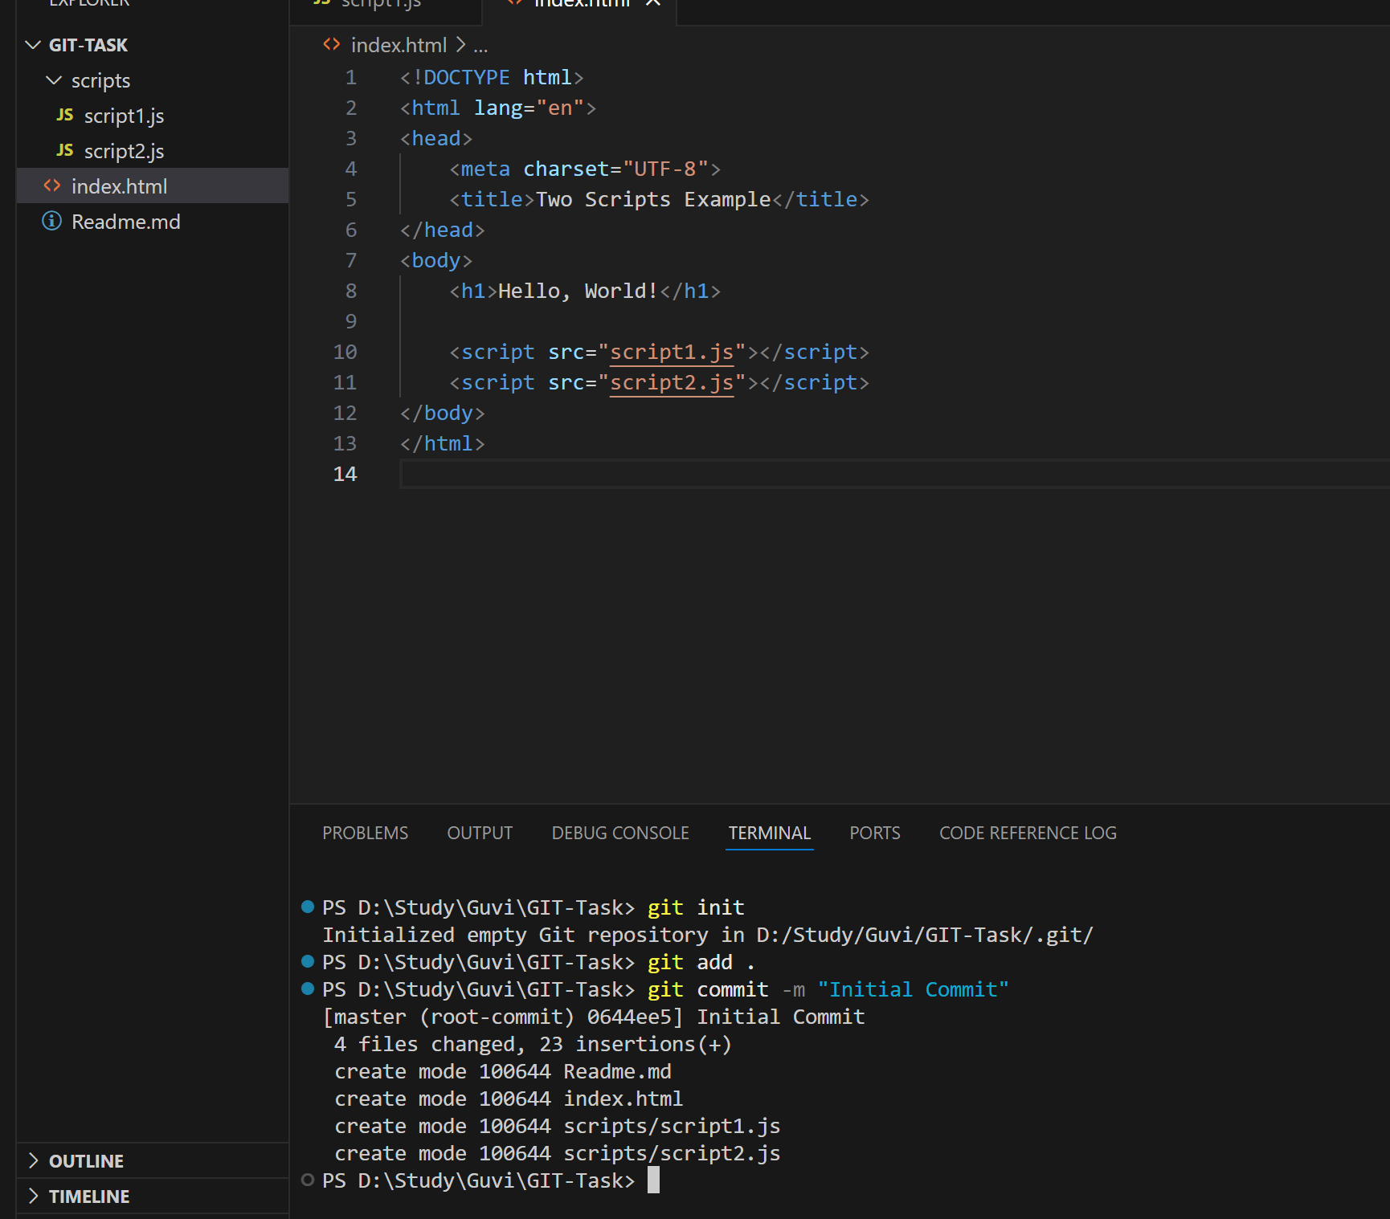

Create a empty repo in GIT

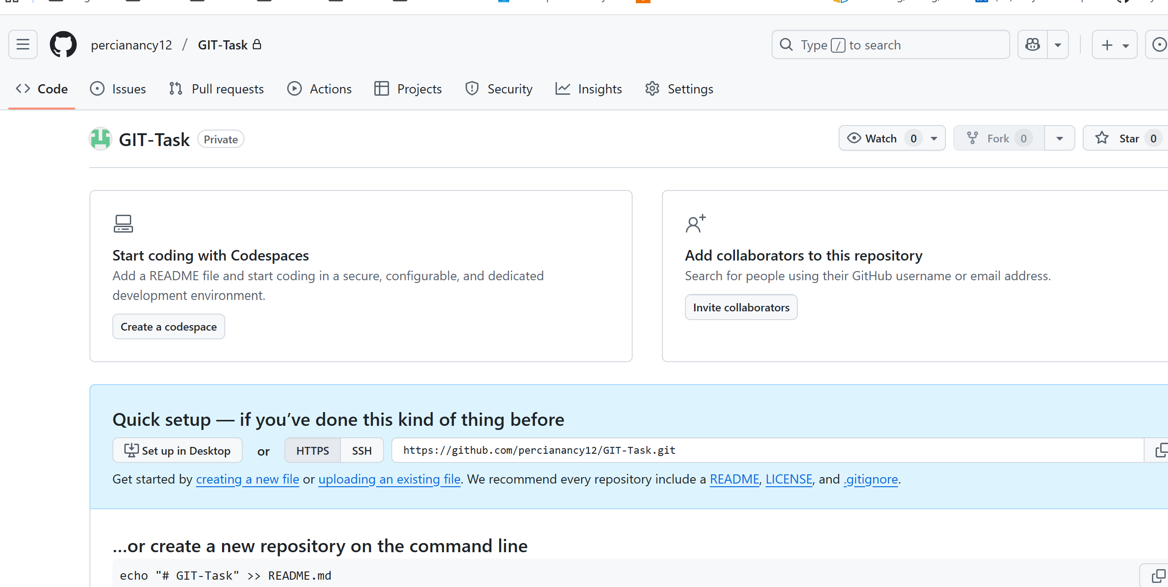

Link the directory with Github

Created master branch and push the changes

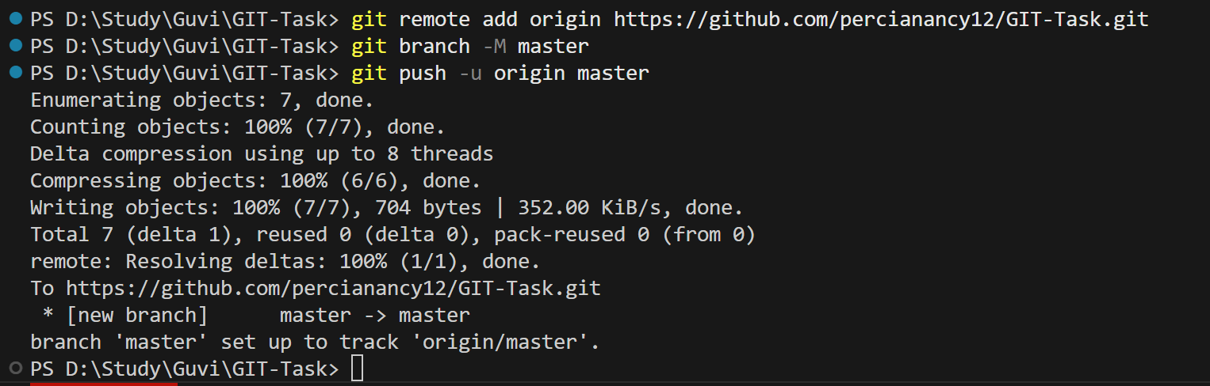

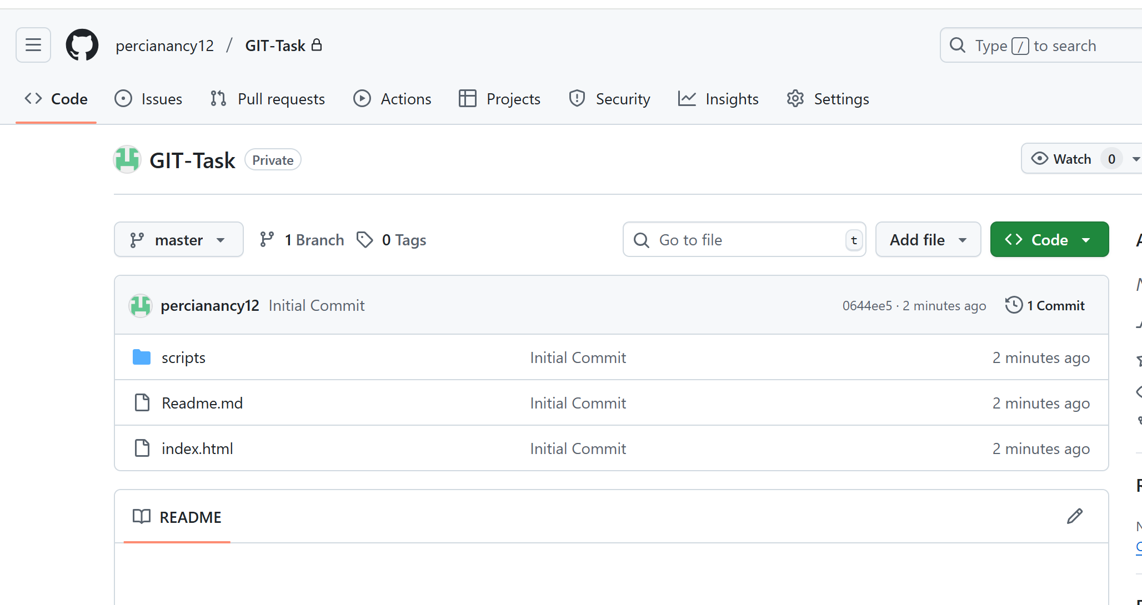

Merge:

Create new feature branch. Added some changes in feature branch, commit and push it. Merge the branch to master

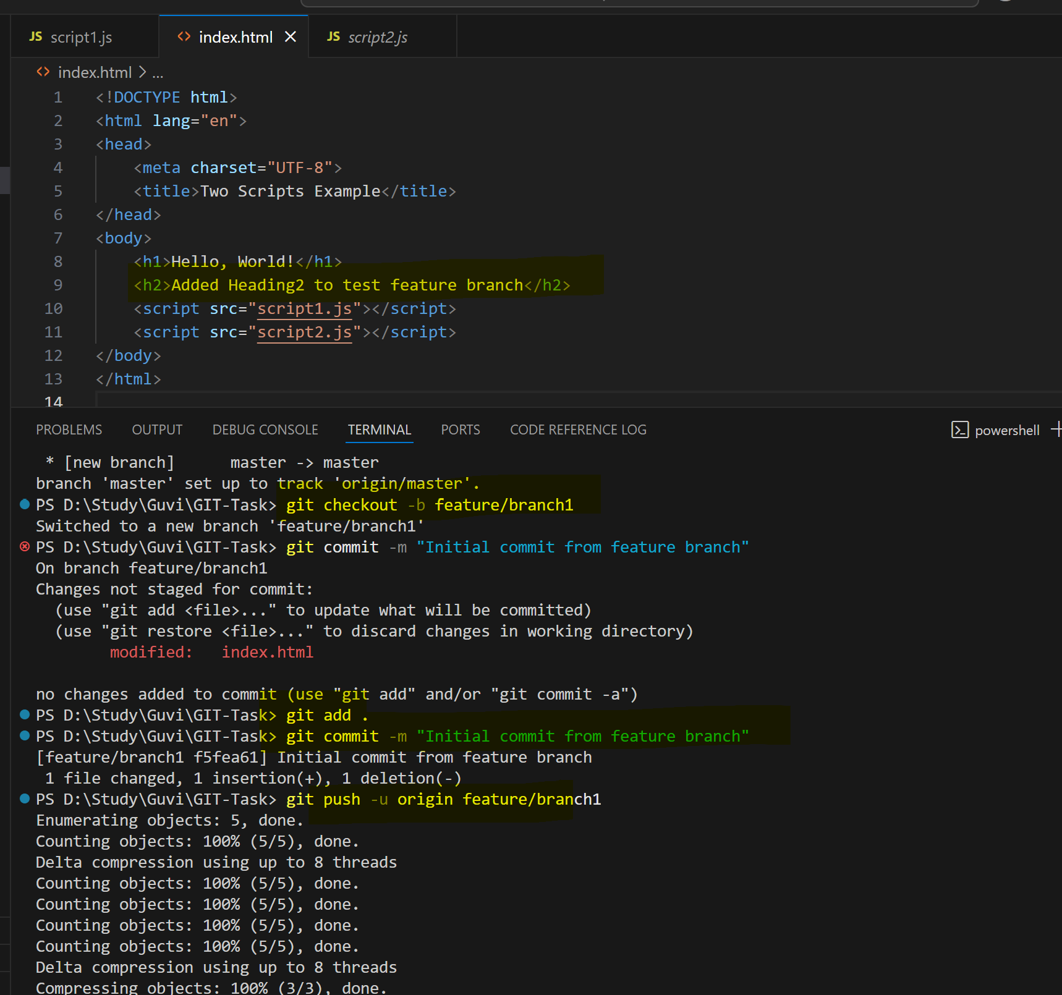

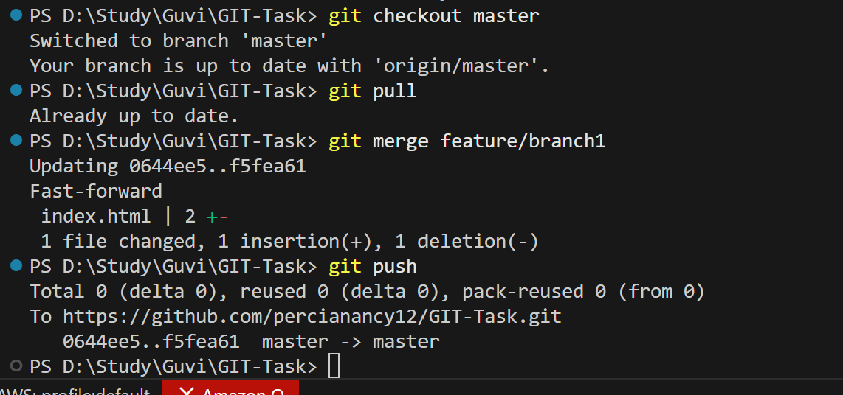

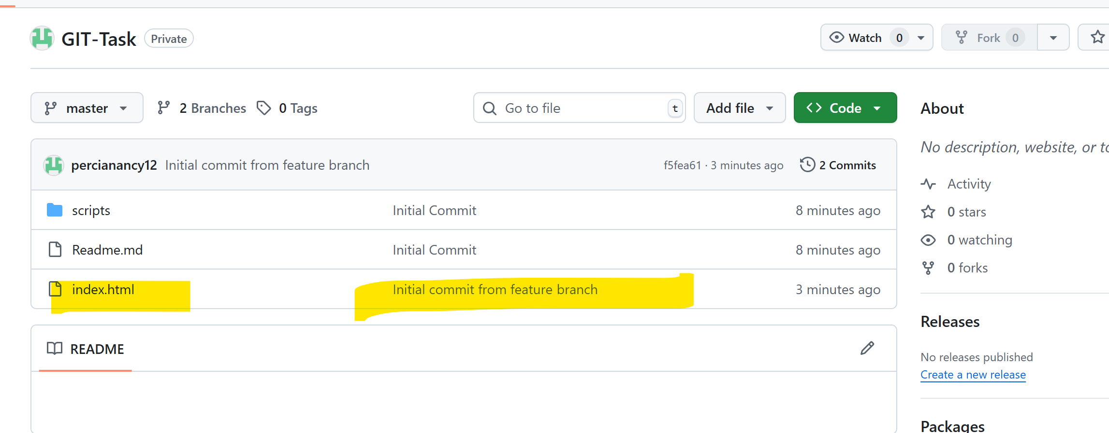

Rebase

Rebased the feature branch changes to master and pushed it

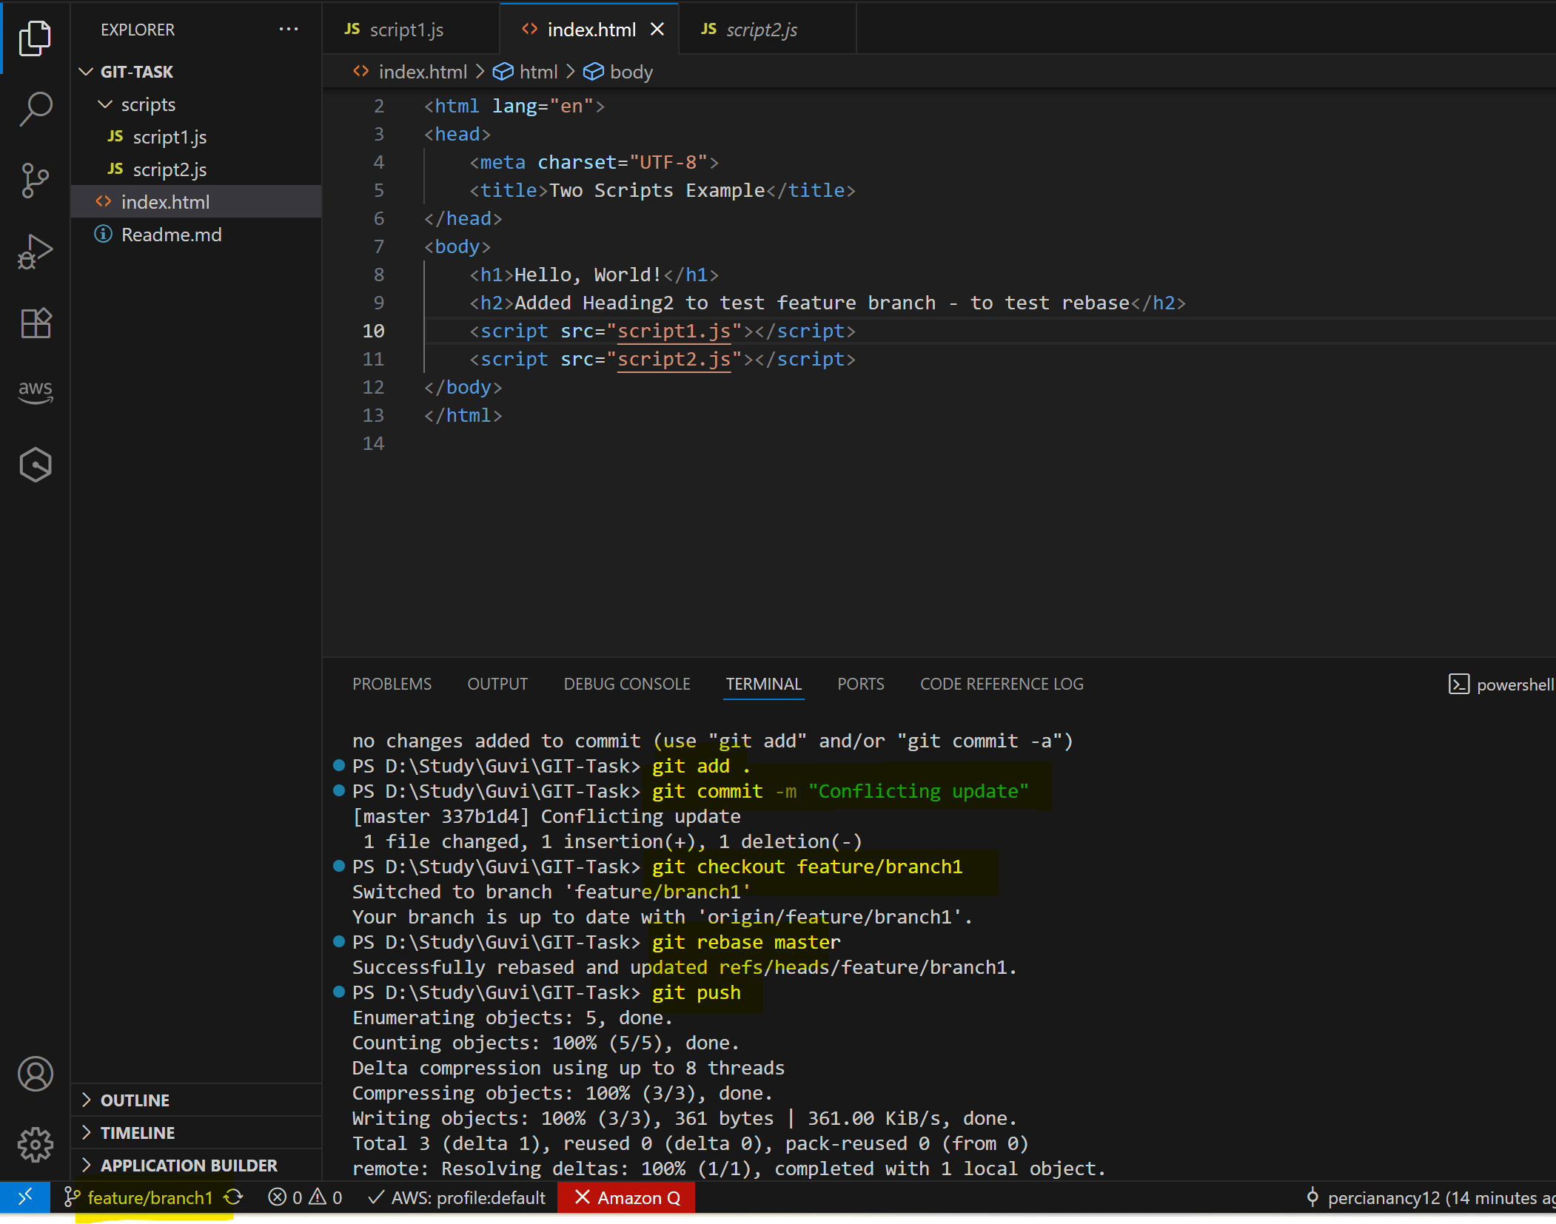

Stash

Made changes in master branch and stash it.

Merge the feature branch to master and apply the stash

Got conflicts fix it via Visual Studio code resolve conflicts. Once it is resolved commit and push your changes

